**Queue in C**

Queue is work on the principal of **First-In-First-Out (FIFO)**, it means first entered item remove first. Queue have two end front and rear, from front you can insert element and from rear you can delete element.

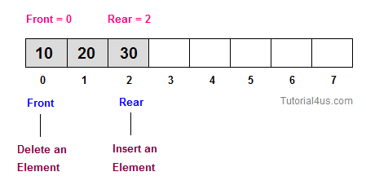

**Real life example of Queue**

A common example of queue is movie theater ticket counter, there first person who stand in front of ticket window take ticket first and remove from line and new person always stand in line from end.

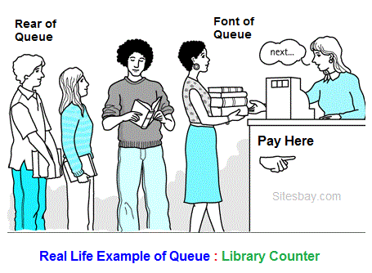

**Single-Lane One-Way Road:** First car go first

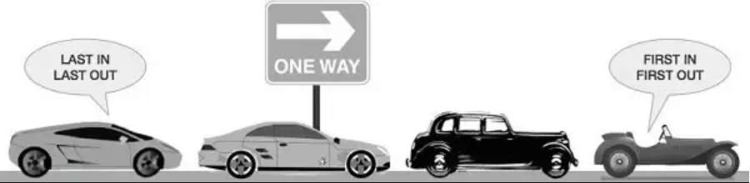

**Ticket Counter:** First person get ticket first and go out first

**Some other Real Life Examples of Queue are**

* Queue of processes in OS.
* Queue of people at any service point such as ticketing etc.
* Queue of packets in data communication.
* Queue of air planes waiting for landing instructions.

**Application of Queue Data Structure in C**

Queues are used for any situation where you want to efficiently maintain a First-in-first out order on some entities. Transport and operations research where various entities are stored and held to be processed later i.e the queue performs the function of a buffer.

In a multitasking operating system, the CPU cannot run all jobs at once, so jobs must be batched up and then scheduled according to some policy. Again, a queue might be a suitable option in this case.

**Operation on a queue**

The basic operation that can be perform on queue are;

* Insert an element in a queue.
* Delete an element from the queue.

**Insert an element in a queue.**



In queue insert any element form **Rear**. If you insert new element in queue value of Rear will be increased by 1.

**Insert element in queue**

**void** insert()

{

**int** item;

printf("Element : ");

scanf("%d",&item);

**if**(front==(rear+1)%3)

{

printf("Queue is Full");

**return**;

}

**if**(front==-1)

{

rear=front=0;

}

**else**

{

rear=(rear+1)%3;

}

cque.cqueue[rear]=item;

printf("Successfully Insert");

}

**Delete any element from the queue.**



In queue delete an element form **Front**. If you delete an element from queue value of Front will be increased by 1.

**Delete element from queue**

**void** **del**()

{

**int** num;

**if**(front==-1)

{

printf("Queue Empty");

**return**;

}

**else**

{

num=cque.cqueue[front];

printf("Deleted item : %d",num);

}

**if**(front==rear)

{

front=-1;

}

**else**

front=(front+1)%3;

}

**Example of Queue**

#include<stdio.h>

#include<conio.h>

**void** insert();

**void** **del**();

**void** display();

**struct** circ

{

**int** cqueue[5];

};

**struct** circ cque;

**int** rear=0,front=-1;

**void** main()

{

**while**(1)

{

**int** num;

clrscr();

printf("1.Insertion\n2.Deletion\n3.Display\n0.Exit\n");

printf("\n\nSelect Option : ");

scanf("%d",&num);

**switch**(num)

{

**case** 1:

insert();

**break**;

**case** 2:

**del**();

**break**;

**case** 3:

display();

**break**;

**case** 0:

**exit**(0);

**break**;

**default**:

printf("\n\n Invalid Option ");

}

getch();

}

}

**void** insert()

{

**int** item;

printf("Element : ");

scanf("%d",&item);

**if**(front==(rear+1)%3)

{

printf("Queue is Full");

**return**;

}

**if**(front==-1)

{

rear=front=0;

}

**else**

{

rear=(rear+1)%3;

}

cque.cqueue[rear]=item;

printf("Successfully Insert");

}

**void** **del**()

{

**int** num;

**if**(front==-1)

{

printf("Queue Empty");

**return**;

}

**else**

{

num=cque.cqueue[front];

printf("Deleted item : %d",num);

}

**if**(front==rear)

{

front=-1;

}

**else**

front=(front+1)%3;

}

**void** display()

{

**int** i;

**if**(front==-1)

{

printf("Queue Empty");

**return**;

}

**else**

{

printf("\n\nItems : ");

**for**(i=front;i<=rear;i++)

{

printf(" %d",cque.cqueue[i]);

}

}

}